**House Price Dataset**

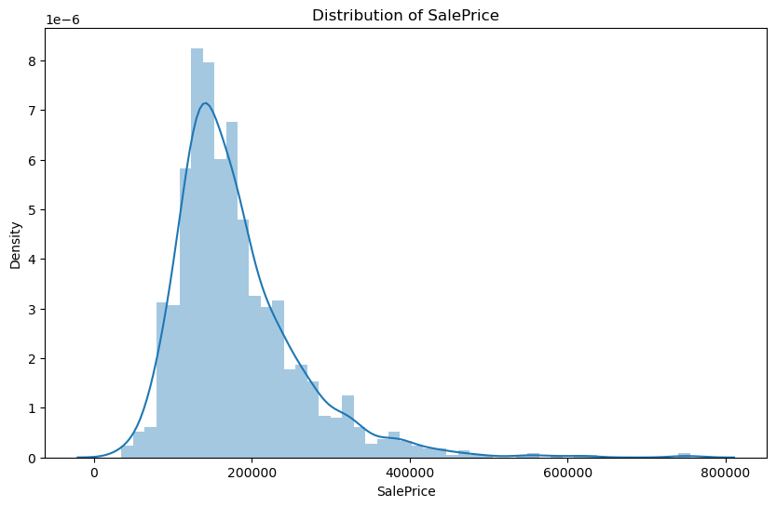

The distribution of SalePrice is right-skewed, which means that there are some very expensive houses in the dataset.

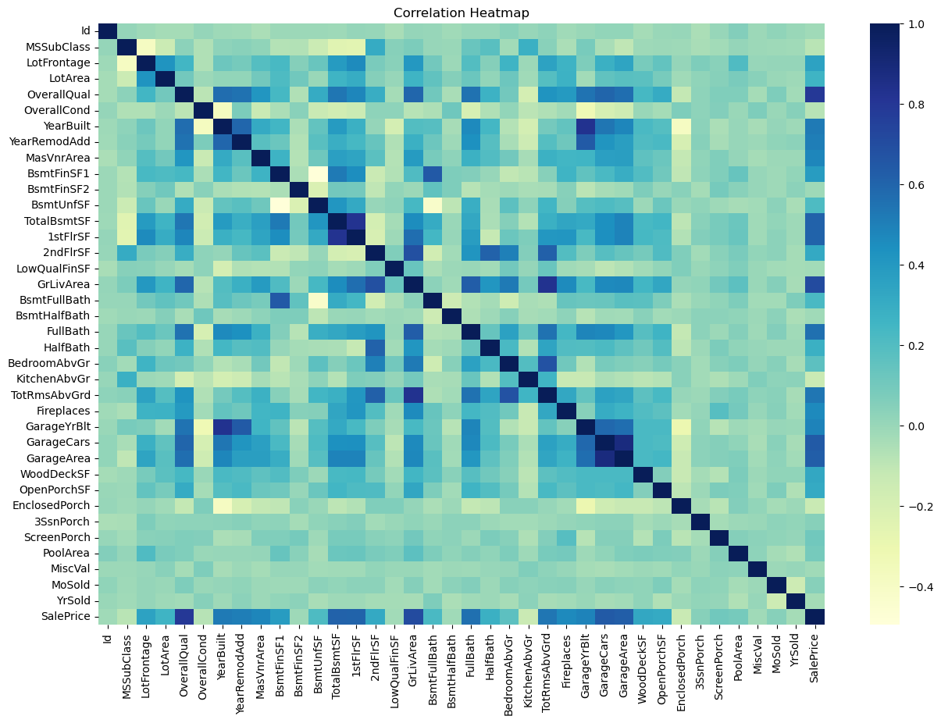

We can see that there are some variables that are highly correlated with SalePrice, such as OverallQual, GrLivArea, GarageCars, and GarageArea.

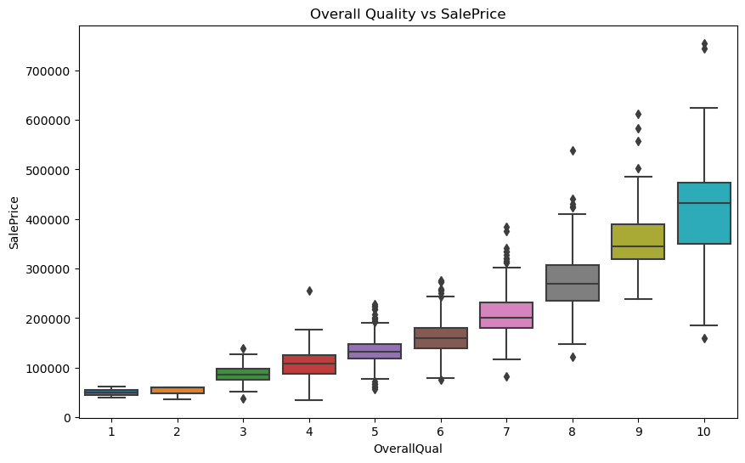

There is a clear relationship between OverallQual and SalePrice, as houses with higher overall quality tend to be more expensive.